Meeting | Warkworth Road Infrastructure Forum | 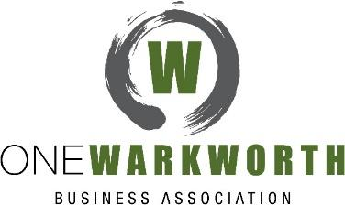
Chaired By | Hon Mark Mitchell, MP Rodney  Chris Murphy, Chair of One Warkworth
Date | Wednesday 23 February 2018
Location | Warkworth RSA
Minutes | Christine Hill

Attendees | Ryan Bradley Auckland Council Carolynne Phillips NZ Parliament  Paige Farley Hutchinson Consulting Eng. Kelli Sullivan NZTA  Grant Reddell Northwood Development Ltd Hugh Leersnyder Northern Express Group  Liz Sharek Matakana Community Group Murray Chapman One Warkworth  Penny Webster Matakana Coast Tourism Beth Houlbrooke Rodney Local Board  Marja Lubeck NZ List MP Rob Bradley Turnstone Capital  Ellen Barrett Auckland Transport Steve Haycock Warkworth Area Liasion Group  Kimdon Nguyen Bruce Scoggins  Nahri Salim Glyn Williams  John Stokes Roger Williams

Minutes of the meeting

Welcome and Introductions
Chris Murphy opened the meeting (Mark Mitchell to join the meeting later).
Forum Code of Conduct reiterated: open discussion welcomed * the final minutes are the official and only record of what is discussed and agreed * public statements about or resulting from these meetings to be circulated for review and approval by all attendees before release * trust and good faith created by these meetings not to be abused.

Confirmation of minutes of the last meeting
Moved – Beth Houlbrooke, seconded and passed unanimously.

Puhoi to Warkworth State Highway extension (RONS)
Hugh Leersnyder (Key Relationship Manager, NX2)
Construction began January 2017 – largely prep work for the major earthworks season that began October 2017. January storms did impact progress so doing weekend and night work in remote areas to keep pace.
Design work is hitting the targets keeping construction teams on track.
In parallel with construction, Urban Landscape Design Framework plans are being prepared to define how the road looks long term. Planning is in 3 parts – middle section (least people impact), Puhoi area, and then Warkworth (Ww) area – with public engagement.
The Hill St intersection site-specific Traffic Plan avoids as much as possible using the intersection, but material will be transported from eastern quarries at some point on truck & trailer units.
Plan is to control the number of units and their timing through the intersection and provide driver induction to ensure considerate intersection use. The Plan is AT and NZTA approval and now in place.
Given RoNS haul roads have gone in relatively quickly can the Matakana Link Road not be developed more quickly to act in the first instance as a haul road for RoNS trucks? NX2’s PPP contract does not include the MLR so no control over this. (AT comment to this below)
At the last WALG meeting an issue was raised of cone layouts & road layouts w.r.t safety. Hugh has passed to the relevant traffic section.
ACTION: Hugh Leersnyder to follow up on the issue of cone/road layouts and safety raised at the last WALG meeting.
Chris Murphy thanked Hugh for his communication with WALG and now the Forum and noted the value in Penny Webster’s suggested use of the MLR as an interim haul road.

Warkworth to Wellsford State Highway extension (RONS)
Kelli Sullivan, NZTA
A letter has gone to property owners affected by the proposed project. It contains no new information in respect of the project but refers to the Government Policy Statement (GPS) under development. The draft GPS is to be released to local councils in early March 2018 for feedback. The Minister expects the GPS to be completed end of June 2018.
The Minister of Transport has indicated that the new GPS will have quite a different emphasis from the previous GPS published in 2015. The signals given by the Minister include prioritising safety, improving access to liveable cities and thriving regions through increased investment.
The new GPS will strongly influence which parts of the existing work programme are progressed and when.
The NZTA cannot comment on plans for specific transport projects, including Ww to Wellsford, until they have greater certainty about what the final GPS will guide us to invest in; and which projects we will deliver to meet the new Government priorities.
Meanwhile the NZTA consultants are still working toward Notice of Requirement.
That Minister Shane Jones was reported in the media as ruling out investment in four-lane highways in the north was misleading: four lanes have been recommended for two sections of the Auckland to Whangarei corridor in the NZTA’s 2016 Auckland to Whangarei Programme Business Case. The Detailed Business Case for Whangarei to Te Hana, currently underway, will be informed by the new GPS.
A four-lane highway can be designed as either an expressway (potentially Whangarei to Marsden Point turnoff) or to motorway standard (Puhoi to Wellsford).

Matakana Link Road
Kimdon Nguyen, Project Manager MLR
AT have begun talks with affected landowners. The alignment has been refined and geotechnical investigations done.
The Notice of Requirement will be lodged end of next week (02Mar18) with Auckland Council (AC) after which the submissions process begins. The hearing is planned for around August 2018. Between lodgement and hearing date AT will talk with affected land owners about their concerns. Any appeal to the NoR could potentially delay construction beginning at the start of October 2018.
The planned development of the MLR enables it to function as a haul road, but only to get materials to the MLR bridge site. Use of the MLR by additional (RoNS) traffic could impact on construction planning, and the timing of the building of the bridge itself would be an issue.
AT have had dialogue with, and have incorporated into the Resource Consent, some comments from, the landowners and developers. There will be some refinement post-lodgement, eg to incorporate design work from developers’ RCs. The intention is for acquisition by agreement rather than enforcement and timeframes depend on this.
The acquisitions process will begin once land plans are released and landowners have sought valuations.

Hill St intersection
Overall Design
John Stokes, Investigation and Design Manager, Growth and North West, AT (on behalf of Faisal Al-Obaidi, Project Manager, AT)
Current funding is just for the Business Case and this will indicate land requirement and give an economic evaluation. This project will then be prioritised against other projects in Auckland.
Mott McDonald engineering consultants were engaged last December and have been identifying problems, objectives and benefits; will do investment logic mapping; have been reviewing historical data for the area; and will develop a long list of options to be subjected to a multi-criteria analysis evaluation.
Public consultation is still some time away with the preferred option not announced until late 2018/early 2019.
Local interest groups will be invited to have a rep on a community advisory group. This will enable their input and information sharing to inform project managers from AT and Mott McDonald also in attendance. The invite and Terms of Reference will be issued in the next 2-3 weeks with the first meeting in April/May. Committee discussions will be in confidence, but reps may report back to their organisations, and to the wider public where appropriate.
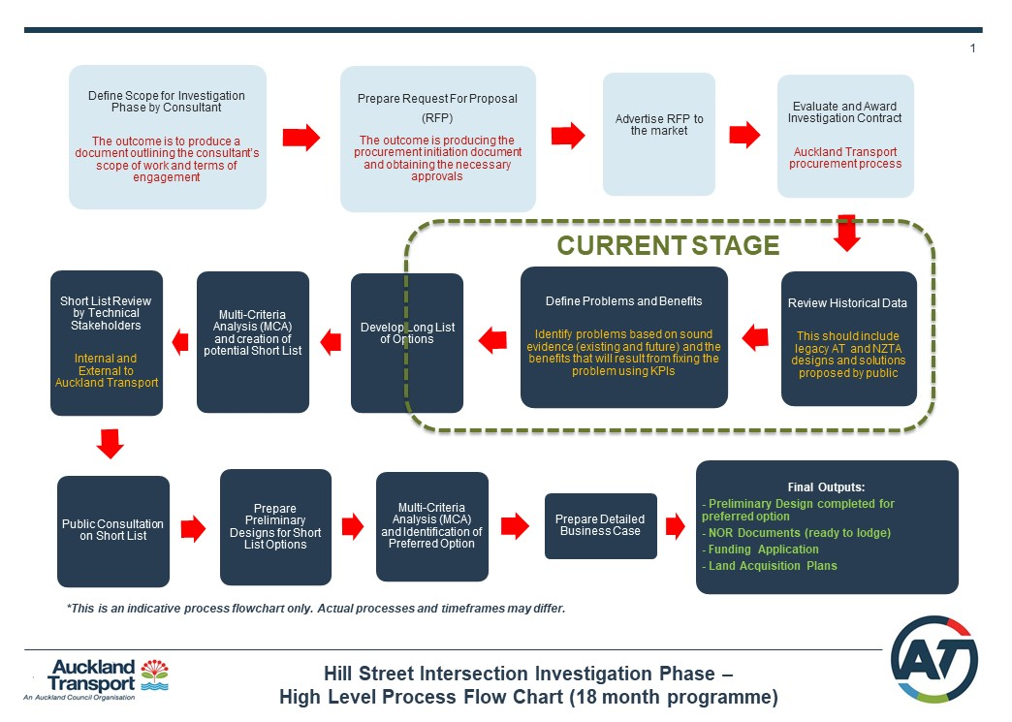
Greg Sayers noted that the timeline is earlier than expected which is very pleasing.
NZTA/AT had talked about a permanent solution for the intersection after completion of the Puhoi to Ww RoNS. Does an agreed solution in early 2019 support implementation earlier, with community agreement? John said the business case would control that and an evaluation for timing will be done in 2019.
There is a cut-off line w.r.t. the available budget and it depends on the economic evaluation whether the Hill St project is above or below that line. John was unclear what the on-going process is should the project fall below the line.
Glyn Williams believes Mark Mitchell has stated that the budget is available to do the Hill St project while Chris Murphy understands part of the design process is centred on making it cost efficient.

Interim Solutions
John Stokes, Investigation and Design Manager, AT (on behalf of the Interim Project Team, AT)
Beca Consultants have completed traffic modelling which NZTA/AT are now reviewing. Early March update about whether a signalised left hand turn into Sandspit Rd and a signalised pedestrian crossing are viable. There will be a general review of the lights phasing for the intersection with the addition of the slip lane lights.
Penny Webster raised the issues facing Snells Beach to Ww motorists, especially the short light phasing to turn north onto SH1. Need more detector loops to determine light phasing.
Chris Murphy apologised for his quote about the barrier arm, “That’s stupid”, which was published in a local paper. The comment had followed a lot of discussion around safety concerns which was not published.
Whilst the Elizabeth St barrier arm is still on the table, it is apparently unlikely to proceed.
Speed reduction on Matakana Rd coming down into Hill St intersection is not part of the interim solution. Beth Houlbrooke stated it is part of an RLB review of limits and a slow process to bring about change. Penny Webster felt a speed reduction into Sandspit was brought about by local insistence despite not fitting official criteria for a reduction. However, Beth believes the formal process is the only way to get the speed down Matakana Rd reduced.
The RLB is seeking costings to put footpaths down Matakana Rd into the intersection.
Is yellow cross-hatching to be painted in the no-stopping area within the intersection? While believing it to be in the plan, John couldn’t comment on behalf of the Interim Solution team.
ACTION: John to request Warren Budd (AT) to provide an update on the interim measures for Hill St intersection.

Western Collector
This currently sits with the Supporting Growth Alliance (SGA) which:
- Is a response to central and local government identifying the need to route-protect new roading connections in growth areas, otherwise AC finds itself a step behind development.
- Is an alliance with the NZTA and AT.
- Includes representatives from 2 consultant engineering companies and from 2 law firms.
- Is tasked with route protection within a 5-year timeframe via a fast tract route designation process. Key areas identified for route protection include Ww.
Chris Murphy asked whether the SGA could meet soon with the Ww group that produced the Spatial Plan given land development in north Ww is progressing quickly – 5 years will be too late. This issue is recognised by AC and the SGA are working with them on the Ww Structure Plan (SP). Ryan Bradley is happy to discuss the Ww SP project later in this meeting.
ACTION: John Stokes to advise the SGA that the Ww Spatial Plan team wish to meet with SGA representatives.
ACTION: Chris Murphy to organise a meeting between the SGA and the Spatial Plan group.
Ryan Bradley noted that one of the main inputs of the SGA would be to produce an Integrated Transport Assessment (ITA) to support the Structure Plan. The ITA needs to be based on a land use plan. The AC Structure Plan process anticipates that a draft land use plan will be ready in the middle of 2018 for the SGA to produce the ITA. The SGA will also be involved in developing the Land Use Plan with Council and other stakeholders. Chris Murphy pushed for discussion sooner than later because it is no use to have a LUP developed independently from private developers Resource Consents lodged.
Rod Bradley confirmed that Turnstone Capital are scheduled to lodge their private plan change for Ww North West to SH1 lodged by 9th March and that their SP may differ from ACs’. They have offered to AC all their data and information used to create their SP and will continue to consult with them. If AC rejects their plan Turnstone may turn to the courts.
Turnstone have offered to provide a copy of the scheme plan to this forum showing their planning of a proposed Western Collector and its relationship to SH1, and the connectivity through the MLR intersection and at the Southern end to Maunsel Drive.
The Western Collector (timing not yet determined) has been of concern over the course of these Forum meetings. It is becoming increasingly difficult to see how it might work. It is hoped that the SGA will resolve this.
Ryan Bradley said the SGA will look at the Western Collector route in the SP process, which anticipates having a draft plan out to the public by end of 2018.

Southern Interchange
The decision on a southern interchange (SI) sits with the SGA and will be addressed through the SP.
In the current RoNS build process, designs don’t preclude an interchange, but that is all as it is not included in the PPP contract which would be too hard and costly to vary.
Ryan Bradley thinks it highly unlikely any enabling works would be done now through the NX2 contracts to build the road, subject to official confirmation. AC supports a Southern Interchange in principle and the SGA will do the work to determine whether it is needed or not before any work on it proceeds.

General Business
Mark Mitchell gave his apologies for his late arrival.
- Hill St Intersection
Grant Riddell, Warkworth resident
As a resident very local to the intersection, Grant gave his overview of the problems and the community impact and noted his key intersection problems: Cars turning out of Elizabeth St in heavy traffic, the southbound slip lane off SH1, and the number of give ways.
Suggested interim solutions to do immediately:
- Make the southbound slip land a compulsory stop
- Get rid of the west bound give way entering the intersection from Sandspit Rd
- Cross hatch the intersection no stopping areas
- Convert the slip lane from Sandspit Rd into Ww to include the southbound lane onto SH1
- Convert the west bound lane from Sandspit Rd to be only west into Hill St and north onto SH1.
Chris Murphy noted that these suggestions are timely because interim measures are being tabled and discussed now. He suggested Grant liaise with Roger and Glyn of WALG to be included in liaison with AT and NZTA.
While the time taken to get action on Hill St has been very trying, the decision to start the permanent solution relies on design work and land acquisition. Whether it is implemented before or after the RoNS finishes is a community decision. Mark Mitchell noted that the widening of Whangaparaoa Rd had massive community support…until it started. Residents quickly called for reinstatement of the existing road. Must consider carefully the stress to be caused by an earlier start to the permanent solution and to ensure community support.
- Warkworth Structure Plan
Ryan Bradley, Policy Planner, Auckland Council
Talked to the Unitary Plan regarding Ww land marked Future Urban Zone (FUZ). Cannot be developed until the SP is done and it is live zoned. As follows, the Structure Plan (SP):
- Will produce a Land Use Plan – new roading network, local centres, residential land, industrial land, parks etc.
- Won’t review the Rural Urban Boundary location.
- Won’t change the future urban land supply strategy.
- Won’t look at existing live zoned areas, ie existing residential areas, town centre.
- The timing of the plan changes to ‘live’ zone the Future Urban zone areas will reflect the Future Urban Land Supply Strategy’s split of Ww development into 3: north ready for development in 2022 when the RoNS and MLR are completed and a new wastewater treatment plant is online, south & north east to be developed much later.
- Once completed will amend the UP by 2021 so that in 2022 we will have bulk infrastructure and live’ urban zonings in place.
- The project is now in the background research phase with consultation beginning this April and independently facilitated community workshops in June.
- Will be in draft by end of 2018 with the final version early in 2019.
NOTE that the UP has legal effect w.r.t. zoning whereas the SP has no legal weight – it is a policy document.

Industrial Area Concerns:
Encroachment of residential land. A buffer zone is needed, and the SP is looking into this. As a satellite town, AC wants Ww to be as self-sustaining as possible for jobs so wants an appropriate portion of the FUZ land zoned industrial / commercial to sustain jobs for 30k people. If too much industrial land is zoned will there be enough residential land to house the labour force needed? The needs of larger employers must be understood by the SP team. Ryan agrees and noted that they are developing a topic paper on business land demands.
ACTION: Ryan Bradley to attend the One Ww Industrial Forum meeting on Friday 2 March.
Land outside the rural urban boundary falls outside the Warkworth SP project. The next chance to change that land zoning is the UP review in around 10 years’ time or through a private plan change. The council will monitor the uptake of Future Urban Zoned land for development through its responsibilities under the National Policy Statement on Urban Development Capacity. Ryan thought it unlikely that land currently designated FUZ will fill up within 10 years.
Mark Mitchell: Must ensure that residential properties only come on line after the infrastructure and that residential development then feeds into business employment needs – timing is essential.
- Matakana and Sandspit Roads Issues
Chris Murphy noted that these issues have been raised within the forum and that in future this will become an agenda item. Relevant community groups will be invited to have representatives attend.
John Stokes said that the SGA do have these routes under consideration.

Next meeting
Next meeting Friday 27 April 2018.
Meeting closed at 09:45am

