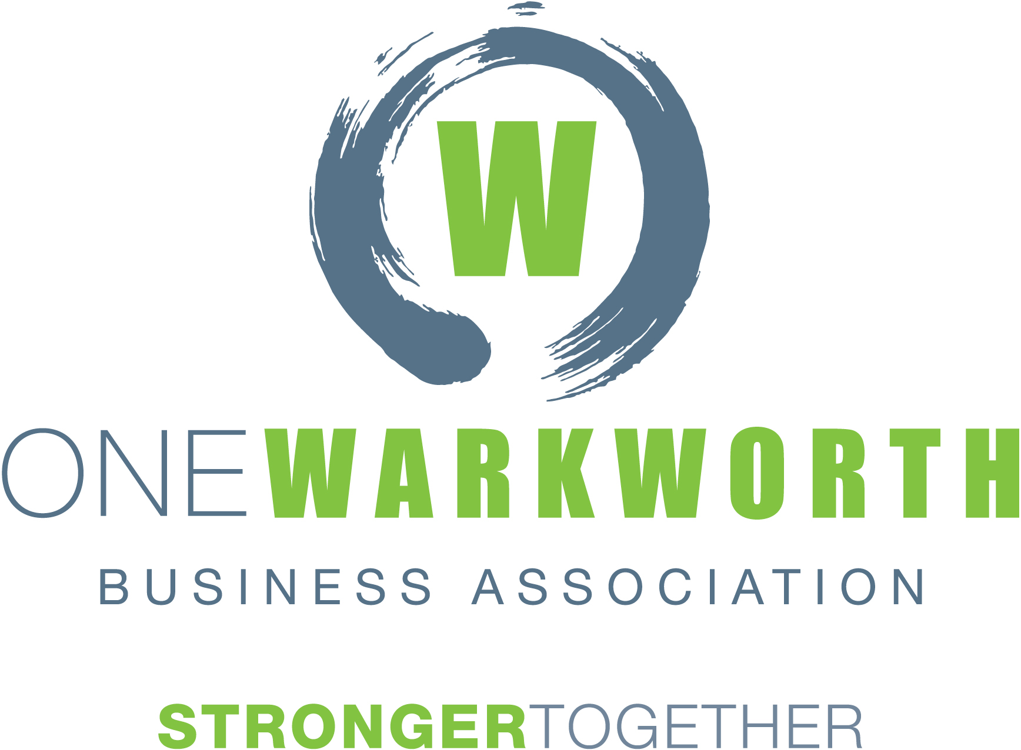

MINUTES
MEETING: | Transport Forum
CHAIRED BY: | Chris Murphy, Chair of One Warkworth Business Association
DATE: | Friday 6 December 2019
TIME: | 8am – 9.45am
LOCATION: | The Boardroom, The Oaks Retirement Village,
Attendees: | Chris Murphy, Murray Chapman Roger Williams, Martin Dancy, Dave Stott, Greg Sayers, Mark Dinniss, Hueline Massey, Steve Mutton, Peter Hartley, Michelle Seymour, Kimdon Nguyen, Melanie Alexander, Bill Endean, Peter Thompson, Mark Macky, Beth Houlbrooke, Ellen Barrett, Liz Sharek, Karen Brown, Karsten Stevenson, Fiona Mayo
Apologies: | Hon Mark Mitchell, Ryan Bradley

Welcome, Introductions and Apologies
Chris Murphy extended a welcome to everyone and outlined the rules of the meeting.
Minutes of last Meeting
Accepted by Dave Stott - Seconded by Roger Williams - All in favour
Matakana Link Road
Update by Kimdon Nguyen.
Tenders closed 4 November. Out of a potential 7 panel 1 tenderers, 4 tenderers have submitted a bid. They have tendered all 4 options so about 16 tenders to review. AT is going through a review and evaluation process, negotiating tags to confirm pricing. Will do scoring for lowest price tenderer next week. Have board approval to award the contract subject to confirmation of acquisition of land, appeals resolutions and funding for the 4-lane option. Currently pursuing the full 4 lane design which currently fits within the budget at this stage – NOTE: tender prices are subject to change through tender evaluation process; potential changes to design resulting from appeal resolutions and potential delays of construction.
6 Appeals still in progress. Last week went through court assisted mediation. Have also done private mediation prior to that. Some side agreements with apellants have yet to be signed. Environment Court is the next step if agreement can’t be reached in April next year with preparation for evidence due by end February 2020.
There is a possibility that appeals could be resolved and works can start next year but the chance of starting this summer is quite low.
ACTION:
Kimdon to provide One Warkworth with a summary of the position as it stands and the outstanding issues so they can approach Mark Mitchell to see if he can advance the discussions he hosted earlier, in the event that this may help.
There is a view that because the process has been left so late the landowners have bargaining power that they wouldn’t otherwise have and if AT goes through their usual process the community will suffer more than it should.
Puhoi to Warkworth SH Extension
Martin Dancy to circulate his list of questions for NZTA to answer regarding the design of the link from the northern connection through the P2Wk roundabout heading towards MLR.
Karsten Stevenson advised that they have constraints around land acquisition. They are currently optimizing the current design so they can still achieve safe tie ins to MLR heading towards Warkworth from the northern connection and still have it in a position which is viable for future widening of that section of road. Looking with those 2 options in conjunction with NZTA so that the RONS can open by 2021. Martin is talking about the pink cross hatched area as you come off the motorway and round the roundabout – its designated as “buried pavement for future safeguarded widening of surface area” on the design.
Karsten Stevenson reported Christmas shut down for their office is from Friday 20th December – back Mon 6th January. There is a traffic moratorium which starts Thursday 19th December – Monday 6th January midday. Disruption should be minimal.

Northern connection – work being done around this area to ensure that once the roundabout is constructed they won’t have to do work on that significantly to do the widening round MLR. Until finalized drawings and land acquisition is confirmed there will be no major update her.

Southern Connection – Finalising stage design coming out of the tunnels – this is complex. There will be disruption at various stages in the future. Will be slowing of traffic. Have found a way to prevent single lane North and South through the tunnel for about 95% of the time.

Things are progressing well with construction.

Puhoi to Warkworth SH Extension – post Opening
Roger would like this to be a new agenda item. The main concern is that we don’t end up with the old state highway in the same condition as the Diary Flats highway which was neglected. We want to start discussions now regarding the changes likely to occur with local and tourist traffic, and particularly cycle touring. The road needs to be planned with this in mind. Issues to consider:

- Major intersections will need to be redesigned.
- This will become an AT road once the RONS opens.
- Will remain a heavy haul route
- Traffic volumes will remain high until the southern interchange is built
- Safe crossing and a walkway for trampers round the Puhoi
Need a formal request to represent these views through the Matakana Coast Trail Trust which is the organization helping to deliver the Greenways plan. Martin is a trustee of this organization and can coordinate. It will also be an item on the first WALG meeting next year (Feb)

ACTION: Meeting attendees to circulate their thoughts on who should be involved in this discussion. One Warkworth would like to be involved with the road issues.
Warkworth to Wellsford
Steve advised the lodgement for the designation and consents still has not been done. They are still working positively through this. It has taken longer than anticipated to get the documentation right.

Hill Street Intersection
Greg Sayers advised there was a local board meeting on Tuesday with Hill St being an agenda item. The information was confidential but Mark Lambert, one of the Senior Managers called Greg with a briefing for this forum. The Board approved the preferred concept design. Money has been allocated to it to take it to a detailed design and business case. This will take about 6-12 months. He reassured that AT has the same objectives as our community to start Hill St when RONS opens. This is subject to funding – there are 2 options – either 50/50 deal NZTA/Community or 75.2% where NZTA will pay the bulk of the bill.

Steve Mutton confirmed that this was correct. As soon as the endorsed business case goes through the NZTA delegations committee they will then be able to sit down with CAG and go through it.

Steve advised that the funding has not been allocated as yet, it still needs to go through the NZTA delegations committee, so it is subject to agency funding. Beth advised we should use the budgeting round to make a submission on it – just keep putting it in front of all organisations involved. The Auckland Council annual budget is consulted on between 21 Feb and 21 March next year.

ACTION: Steve to advise the forum when the funding has been allocated for Hill Street.

Melanie Alexander on Interim works
Improvements being made to footpaths along Sandspit & Matakana Rds. Following that the interim works will start around January. Will take a few weeks and includes traffic lights and the speed table as well as hatching and connected footpaths.

Also, they have received a number of concerns with traffic coming from Eastern beaches. There have been problems with the traffic load detection leads were cut and their smart technology wasn’t working. They were reinstated last week so should be better now.

Greg highlighted that this is a great source of frustration and is a big issue.

Western Corridor / Southern Interchange /Traffic Modelling
Update by Michelle Seymour and Peter Hartley – Supporting Growth (attached)
Supporting Growth programme covers all future zoned land. They have indicative networks showing where the corridors should be. Over the next 2 years they will be doing detailed business cases for these corridors followed by Notices of Requirement to secure designations. Started on parts of the NW & South which is live zoned already. 2020-2021 they will start Warkworth as these need to be rolled out in stages. The process is:
- Indicative business case
- Detailed business case
- Board approval to start NOR process
- Detailed design proper to implementation – (not Supporting Growth)

There is opportunity for the business case to be consulted with community. Dedicated open day sessions, flyer drops etc. They appreciate feedback on how communities would like to get involved.
Western Corridor - Dave Stott and Roger Williams have considerable concerns. Michelle advised that major changes to the endorsed indicative plans will most likely not happen. Minor ones will be considered such as the Mansel Drive issue will be addressed during the business case.

Activity happening now that may be affected by any changes. Michelle advised that until the designation is in place they can ask if a developer can allow for it but can’t force a developer to not build there.
Southern Interchange – is in the indicative business case, in the structure plan. Will be investigated further as part of the detailed business case in late 2020/2021. Then will look to proceed with notice of requirements that fall out of the business case. Timelines proposed in a memo from One Warkworth recently align with those of Supporting Growth except when we would like to see it built. They have no control over construction funding. Advice to One Warkworth is that it is not identified for funding in the current RLTP 2018-2028. One Warkworth would like to push for this to be brought forward to 2023 or as soon as possible. Michelle advised that to fast track this, One WW needs to make clear submissions when the funding round comes up.
Greg has asked for the following questions to be answered to brief the deputy mayor.
- Is it on the ATAP project list?
- Is there any indicative costing around this yet?

Michelle confirmed the indicative Business Case and the Structure Plan currently show the southern interchange as connecting to the wider western link and the existing highway.

There will be discussion about integrating the southern interchange with the release of the southern growth area in Warkworth. Council will want to see these things aligned but it comes down to funding.
Supporting Growth agreed to schedule a one-off meeting early in the process with local groups to share their views.
Traffic modelling – Supporting Growth applied a sensitivity on intersections to the long-term models for the indicative business case and for the Structure Plan. In 2020 they will use updated models calibrated to 2018 base and will address the uncertainties raised at the previous meeting with Roger and Dave.

11. Local Board – Transport Updates (Beth Houlbrooke)
1. Hudson Rd footpath – design has gone out to tender and will be constructed early next year.
2. Park’N’Ride – AT has finished design work, have got all necessary permissions from NZTA and are waiting on the Board to give go ahead to go out to tender. But Local Board are waiting on finding out the extent of remediation work on the project.
3. Transport Targeted rate is $150 per SUIP (Separately Used or Inhabited Part of a rating unit). For WW subdivision, we were collecting $1.9m per year for the subdivision and that money is going straight into the Park N Ride.

12. Land Purchase for New Roads – (Martin Dancy)

Martin Dancy presented Supporting Growth with an opportunity hold a forum with landowners now to discuss the planned “Sandspit Link Road” on the structure plan. Landowners and the Golf Club are willing to put their land forward for purchase. There is already uncertainty amongst them and this opportunity could progress toward a designation in a cost effective, timely and less disruptive manner than may otherwise eventuate.

13. Traffic Back Up on Matakana Rd last Weekend – (Roger Williams)
If modelling is done on weekends when the traffic is heaviest this could alleviate future issues. Beth advised that this weekend’s backlog resulted from the traffic control cameras being deactivated for the roadworks.

Peter advised that one off events are for the public to call in. However, NZTA and AT have an operations centre and engineers who monitor how the network is performing. So there is a record that can be accessed of ongoing traffic counts through the lights.

ATOC have the ability to control the lights. But this hasn’t happened. There is urgency to get all these projects underway as soon as possible, as year on year the situation is getting worse.

14. Mahurangi River Tourism Opportunity – (Peter Thompson)
We are currently looking for funding. Some small donations from community and support from locals is there. We need to show our united support and the need for this.

There is a belief that if we can obtain funding to dredge the river we then open up the opportunity to bring people into the area by ferry which could alleviate pressure on the roading network. Cost to dredge the river is around $4m. The 2nd stage round the back of Snells Beach could provide the base for ferries.

15. General Business

Next meeting February - TBC
Next meeting – When invite goes out next year, forum members will be given the opportunity to submit questions that they would like answered so we can make sure the appropriate people from the relevant agencies are present to answer.

Speed Limit
AT’s speed limit review is complete, and they have announced which roads will get speed reductions, effective 30 June 2020.

For consideration and comment for next meeting. Is it possible to get some clarity on what disruption is to be expected from construction of the waste water pipe from sandspit along Sandspit Rd for quite some distance to get to Warkworth.

ACTION: Supporting Growth to follow up with Watercare and report at next meeting.

Meeting closed 9.55am
Next meeting February – date to be confirmed

