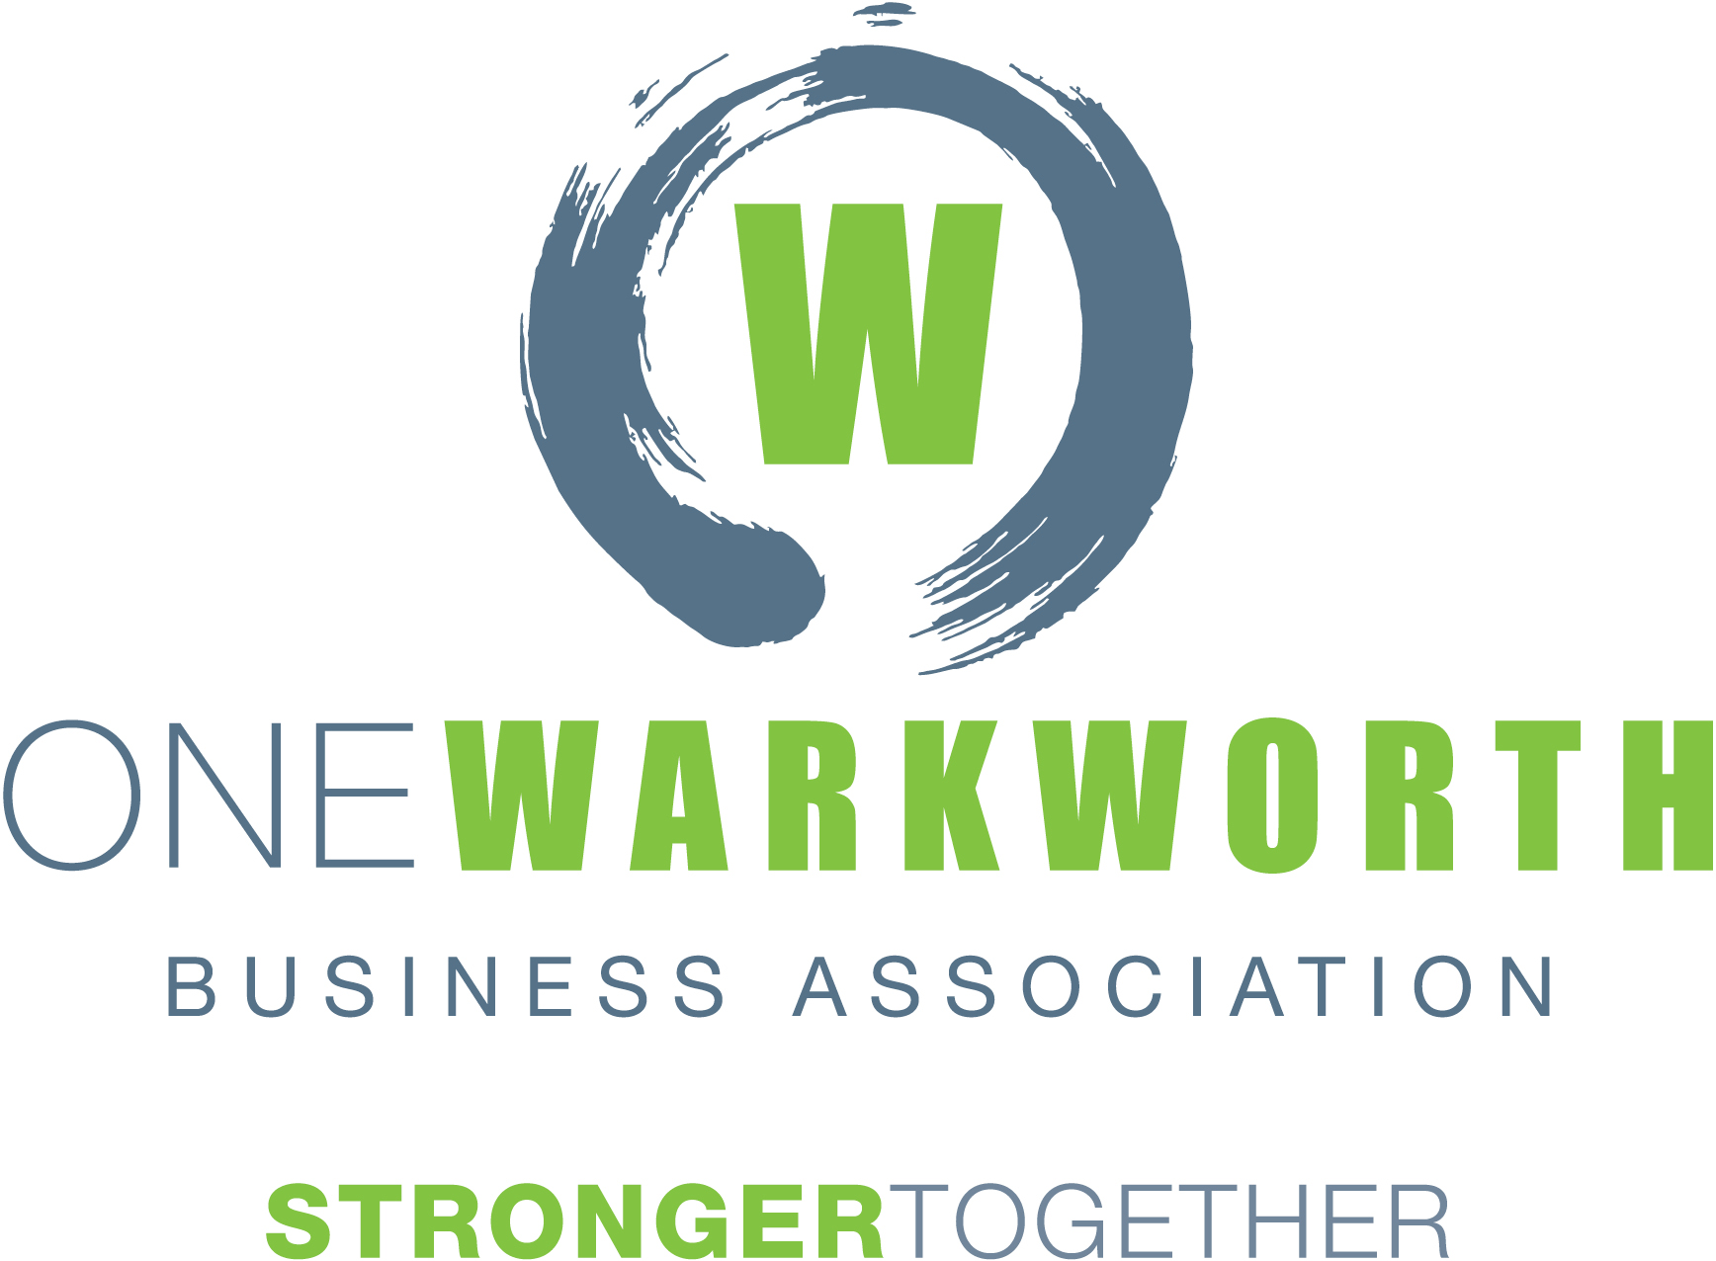

MINUTES

MEETING: | Transport Forum
CHAIRED BY: | Chris Murphy, Chair of One Warkworth Business Association
DATE: | Friday 20th September 2019
TIME: | 3.30pm
LOCATION: | The Boardroom, The Oaks On Neville  Queen Street, Warkworth
ATTENDEES: | Chris Murphy, Mark Macky, Glyn Williams, Murray Chapman, Rachel Herron, Kimdon Nguyan, Mark Edmonds, Kelvin Burgess, Craig Clark, Martin Dancy, Dave Stott, Beth Houlbrooke, Jonathan Green, Maurice Hooper, Peter Thompson, Hueline Massey, Mark McLaughlin, Roger Williams, Marja Lubeck
APOLOGIES: | Hon Mark Mitchell

Welcome and Introductions
Chris welcomed everyone to the meeting and outlined the ground rules for all attendees at the meeting.

Previous Minutes
Confirmation of minutes of the last Transport Forum
Moved: Dave Stott
Seconded: Roger Williams
All in favour

Ryan Bradley has sent his report which was put on the screen and is circulated as an addendum to these minutes.
Essentially, with regards to the Structure Plan, Council have put forward a series of zones which are to come online at different times. The zones intended to be live zoned first for residential are the subject of private applications to Council for consent for private land changes and rather than have both a private land owner and Council push each other’s views across, Council have stepped back and will work within the context of the land owners application to settle the treatment of the land subject to their resource consent application.

In the first stage there is 99 hectares of future urban zoned land. 1000-1200 residential developments are expected also 13 hectares of light industrial land with a neighbourhood centre of 3000 square metres. 2 landowners are working together on the northern part north of the showgrounds for the 2nd private plan change, which should be around 50 hectares or around 1000 houses as well.

So, 2000-2500 households at 2.7 people per household. This is a significant addition to the population of Warkworth with these 2 applications alone and will double the population. So Warkworth will almost be 3 times the size by 2023-2024.

Ryan submitted a list of significant resource consents which have recently been or are currently being processed.

Timeframe from date of application to Council and the date of construction can be 2-3 years, and these 2 applications alone, being approx. 7,000.

Matakana Link Road

Kimdon Nguyen presented an update –
Last Wednesday they released the tenders for construction of Stage 1. This takes into account feedback received from the public throughout the project. Basically, there are 2 design options being tendered – 1 is for 4 lane capacity to just before the bridge and the other is 4 lane capacity across the full length of the Matakana Link Road. In addition, they have managed some opportunities around joint earthworks with some adjacent land owners, so that has added in a couple of other design options to be tendered. Potentially some of the earthworks will be done by the owners. Tenders will close 4 November 2019, subject to appeals process, requisition of land and will be looking to award by the end of this year.

There are 6 appeals to the consents and designation. AT are working with the appellants to resolve issues outside mediation. There is a non-court assisted mediation proposed next week with appellants to discuss key issues and they are still working with the courts to find a formal court assisted mediation date. It may be pushed out in order to be able to get everyone together. This is an incentive for AT to try and resolve the appeals outside of mediation asap. The Environment Court hearing has been set for April next year if we are unable to resolve these.

If it does go to the Environment Court next year, there will be no earthworks this current earthworks season. We would then advise the tenderers and look at how this will impact completion date but would most likely extend the completion date.

Chris: Is the tender put to contractors on the basis that it must be completed by a certain
date?
Kimdon: We have tendered on the proviso that they assume construction will be awarded by
December and targeting October 2021 date. If construction start date is pushed
back they will need to renegotiate with tenderers to see if they can meet the
October 2021 date otherwise that date will be pushed back.

Questions on modelling on the impact on Warkworth’s traffic network should the Oct 21 deadline not be hit should be directed to NZTA.

Martin Dancy: AT has held Meetings with NZTA and landowners. There are 3 issues that were to be addressed:

- Alignment of Pak’n’save car parking,
- To have a long slip road back to the motorway so traffic flows freely along MLR,
- To sort out the ponding / the stream.

Martin’s understanding is that AT and NZTA has agreed to do this but there has been no confirmation that this will happen. AT needs to be willing to move things forward. There are willing landowners but NZTA and AT are dragging their feet.

Kimdon responded – in summary: Discussions and mediations to date have shown NZTA and AT have presented various options for resolution and that there are implications from other projects such as Western Link Road that will impact this project.

Martin responded – with regard to MLR – 90-unit commercial area. This is part of the Unitary Plan – we need to create jobs. Landowners are willing to do what is necessary but AT is not confirming a way forward.

Kimdon responded – Not true – in October 2018 the developers put forward a proposal, Section 92 requests were made outlining additional info that was needed for AT & NZTA to confirm intersection design but we have received no further info to date.

Craig Clark: Kimdon is right about a lot of things discussed. There have been numerous meetings with NZTA and AT re issues on MLR. Word is getting through. Detailed traffic modelling is being done right now. There have been delays from all parties but there is a way forward. AT have not been disruptive in the way they go about things. There is a process to be gone through and we are working through this. There are appellants to aspects of the A&T consent around access. This debate will be held next week or the week after.

If final court hearings are in April – it will take 3 months for a judgement so decision will be July/Aug followed by any appeals.

Martin: all parties need to be working 24/7 together. We need to sit down and sort everything out.

Craig Clark: a lot of issues around this stem back from the NX2 contract and whether NZTA have the ability to alter the design that’s in situ.

Mark Edmonds: NX2 contract includes a requirement for that contract to construct the widening of SH1 between the end of the motorway and the MLR intersection. There are appeals to the agencies designations and consents for that project. SH1 W and AT’s MLR are 2 separate projects but all issues for both projects are to be considered together in terms of the appeal/Env Court process. Work is going on now to talk to appellants for both projects to get together.

Chris Murphy: One Warkworth is very pleased that the MLR works have reverted to 4 lanes and that the work could incorporate intersections which are built later. The ideal situation is that we end up with the 4 lanes, 4 lane bridge, intersections in situ at the outset and that it’s done by October 2021. Any other outcome will prove problematic. Our concern is that AT omitted to start the process in a timely manner. To expect all the process would flow without delay is commercially negligent and had the public works act and acquisition process started 18 months earlier, the community wouldn’t be exposed to the risk it is now. In my view, that is significant motivation for all parties involved in the discussion to be more constructive in their dealings with a view to prevent the need for Environment Court hearing and to enable works to commence this work’s season.

Discussion ensued about landowners being compelled, under the Public Works Act, to sell their land and the issue that AT should have started this process earlier in order to deal with appeals etc in a timely manner to ensure MLR opens at the same time as the RONS.

Kimdon was credited with taking messages from the Transport Forum back to AT and effecting change which has been extremely pleasing, however if the process had been started earlier, we wouldn’t be in the position we are now.

This is a serious issue for the wider community. There must be a way we can all get round a table and resolve these issues as soon as possible.

Martin Dancy: Contract between NX2 and NZTA is very much at the route of this as heavy penalties on both sides if these contracts are not completed, land isn’t purchased. Talking with Mark Mitchell, Minister Twyford and NZTA to move negotiations forward could be very important. Financial implications are strongly affecting this progress.

NZTA and AT are working hard to deliver both these projects within the timeframes announced. But they can’t circumvent the democratic process.

Puhoi to Warkworth State Highway (RONS)
Jonathan Green & Mark McLaughlin presented a visual update on progress of this project with a drone flyover video. And what is coming up on the project for the forthcoming season. Information Centre is open Tuesdays and Thursdays or other times by prior arrangement.

Questions on the project were answered by Jonathan and Mark.

Regarding Hill Street – Chris Murphy advised that community was concerned that volumes of trucks would be using this intersection but there is a traffic management plan and resource consent restrictions for them to avoid this area wherever possible.

Welcome to Marja Lubeck.

Warkworth/Wellsford State Highway
Nobody was present at the meeting to comment on this.

Hill Street Intersection
Surface is being refurbished over the next few weeks – residents affected have received a letter. We were told a year ago that these works would be combined with putting pedestrian crossings at the bottom of Sandspit Road along with these works. Seeking assurance from AT that this will be going ahead as told by a spokesman 2 days ago.

Rachel Herron – NZTA responded: Have got permission for zebra crossing and is assuming this will be going ahead with these works. Rachel will go back to seek confirmation that this is the case.

Weekend of 5-7 October has been reserved for Hill Street resurfacing.
The following weekend is the Kowhai Festival so if there are delays this will be impacted.

Dave Stott has requested another CAG meeting asap. Kimdon has raised this with AT and they will arrange it. Last CAG meeting was in November last year – then they promised to confirm the preferred option in April. No funding had been allocated for design or build. Discussions to date from Council has been that Hill St can’t be built till MLR has been built to ensure the network is there to lessen pressure to the east while the work takes place. The Mayor advised on Monday night that $27M has been allocated. We would like NZTA and AT to come back to us and confirm that this is going to happen.

Design for this needs to start now – we can’t see any budget for it just yet – perhaps this will come from the cancellation of the light rail budget.

Western Corridor
Seems to be pushed forward by private developers. Kimdon advised a meeting with developers is set for next week.
Still serious concerns regarding the use of Mansel Road part of the western corridor but this simply has not been addressed.

There is a notified consent hearing for 224 Hill Road – that will put another 50 houses going through to Hudson Road. If they develop Stubbs Farm from the south there will be huge amounts of traffic going through Hudson Rd so it is really important that we get a western link road in place and open as soon as possible otherwise traffic going towards the new motorway will be chaos along Hudson Rd.

There is also an industrial and retail development by Mitre 10 – stockyard falls which will increase traffic. The industrial area is starting to get cramped, so this has to happen.

Southern Interchange
Advice we have is that there is no will nor money to consider this change before 2028. The request we put to them is that NZTA and AT bring forward their consideration for the Southern Interchange with a view to given thought to enabling works happening within the course of the NX2 build. There will never be a cheaper or less disruptive time for these works to take place. The difficulty is that this will require settling on a plan for location of road but holds the opportunity for a timely designation and public works act application which could avoid the situation we currently have with the MLR. The motivation for this is that the bulk of residential development in Warkworth is to experience is to the west and south. The western connector is going to be dysfunctional because of existing developments and will not be able to carry large volumes of traffic. The only intersection to the state highway is to the north of Warkworth. So, all that Auckland bound traffic will have to either use the old road or negotiate a difficult western corridor or Hill St. So, a southern interchange is the solution to long term traffic woes that Warkworth may otherwise suffer. It has only been on the table since public consultation on the structure plan. It was the most sought roading initiative in the context of the structure plan, surpassing Hill St in the context of public submission. Every single group had it as a priority.

We would like you to go back to the parties who can consider the southern interchange with a view to effecting dialogue which might see something significant happen in 2022-23, given the southern residential zone will be live zoned in 2023. If we don’t have designation and enabling works sorted, we could find ourselves with difficulty.

We need to bear in mind that the NX2 contract was settled before the new structure plan was considered and was only ever planned to account for 4-5,000 people with historical growth to the south of the northern interchange. Within a year or 2 of that contract being allocated the structure plan changed and Warkworth has gone from a town of 6,000 people to one that will be 28-30,000 people in 15-20 year’s time so there is reason for change and its simply a negotiation and variation – there will be a cost but it will never be cheaper.

Traffic Modelling – Roger Williams
Meeting was held in March where technical issues and anomalies were raised. There was no response at that time which was understandable as it was just before the MLR hearing. Would like to thank Kimdon for bringing it back up again and facilitating the meeting yesterday. We raised much the same issues again which were discussed regarding ratios for people per household and timing, need for realistic B/Cs from traffic modelling and for funding and priorities. We did not resolve a great deal, but they agreed to remodel with a 30% increase sensitivity change, which is getting closer to the numbers we had before. They are indicating they are looking at the issues that were raised.

This gives us the opportunity in future to be able to assess those results. If traffic modelling numbers are lower, then we’re not going to get the B/Cs and the priorities that are really there. This means 2.78 will be used to test all these models and this gives us some wriggle room. We would like a response to the documentation on the table.

Kimdon advised that Supporting Growth team has used 2.78 – they have done a 30% increase as a sensitivity test for the whole of Warkworth model which shows the 2.78 persons per household and that will be used to assess projects as part of the structure development.

Previously that number was 2.14 – so we are happy with 2.78.

Local Board Transport Update – Beth Houlbrooke
Local Board has some small transport projects which are significant to Warkworth.

- Footpaths- From Mansel Drive – Falls Rd to connect to the one at the top of Hudson Rd on Hill St (south side) - 50/50 deal with the developer. Also along Hudson Road – from state highway to Albert Road.

These 2 footpaths will provide pedestrian access for residents from the west side to the new
Pak’N’Save, new Park’N’Ride that’s about to be built and the showgrounds for afterschool activities which has the potential to reduce traffic movements out of Hill Street.

- Park’N’Ride
Concept design for 150 car parks at the Atlas site – buildings are currently being leased there, the lease runs out on 30th September. Buildings will be demolished or deconstructed. There will be a footpath from there that will connect through Kowhai Park and we’re working with MLR for some access through the showgrounds. The Park’N’Ride is a local board community facility. There will be shelters and possibly toilets at the site also.

They are funding the 998 bus to Wellsford which is performing better than expected. The aim is to go into the next 10 year transport budgeting round. Warkworth to Silverdale service is running as expected but people have said they’d use it if there was somewhere to park.

It is likely the 995 service will be rerouted around the west of Warkworth. This will make the Park’N’Ride site left had turn in and left hand turn out which will solve a lot of issues we have.

Will provide overflow parking for show grounds on the weekend and will relieve parking pressure in the town centre and side streets around town. Bus congestion will then happen at the Atlas site.

General Business
Martin Dancy: for next time – Auckland Transport have been tasked with purchasing or designating land for future roads around Warkworth within the next five years and I think we need to get involved with that. Would like to see this on the agenda. Chris suggested Martin pens a letter to One Warkworth setting out a request for information from Supporting Growth Alliance on the issues you presented at the last meeting.

Chris requested from attendees a brief list of issues they would like addressed at the next Transport Forum meeting so that AT and NZTA have the opportunity to have an informed person at the meeting to comment.

It is important to note that NZTA and AT are present in a limited capacity at today’s meeting. Kimdon’s reporting has been fantastic and we have seen change we never expected to see.

S/W linking with motorway. There is a possibility that the west of Warkworth will develop industrially and there may be a future need for a link from the west to the motorway.

Meeting closed at 5.15pm

